## IPT10 Laboratory Exercise

### Stripe Checkout

### Introduction

These activities allow the students to experience integration with a payment system like Stripe through its API. Students need to create a Stripe account and use its API for web application integration.

### Instruction

Make a copy of this google document (you will need to submit the URL of your copied docs once you’re finished). Follow the instructions here, tick the box once completed, and paste the code or screenshot here as instructed below.

### Stripe Account

* Register an account with stripe <https://dashboard.stripe.com/register>
  + Choose any country, ex. Australia
* After registration you would need to activate your account through an email that was sent to your inbox
  + Skip the Activate Payments step
* Click the New Business menu to create a business account

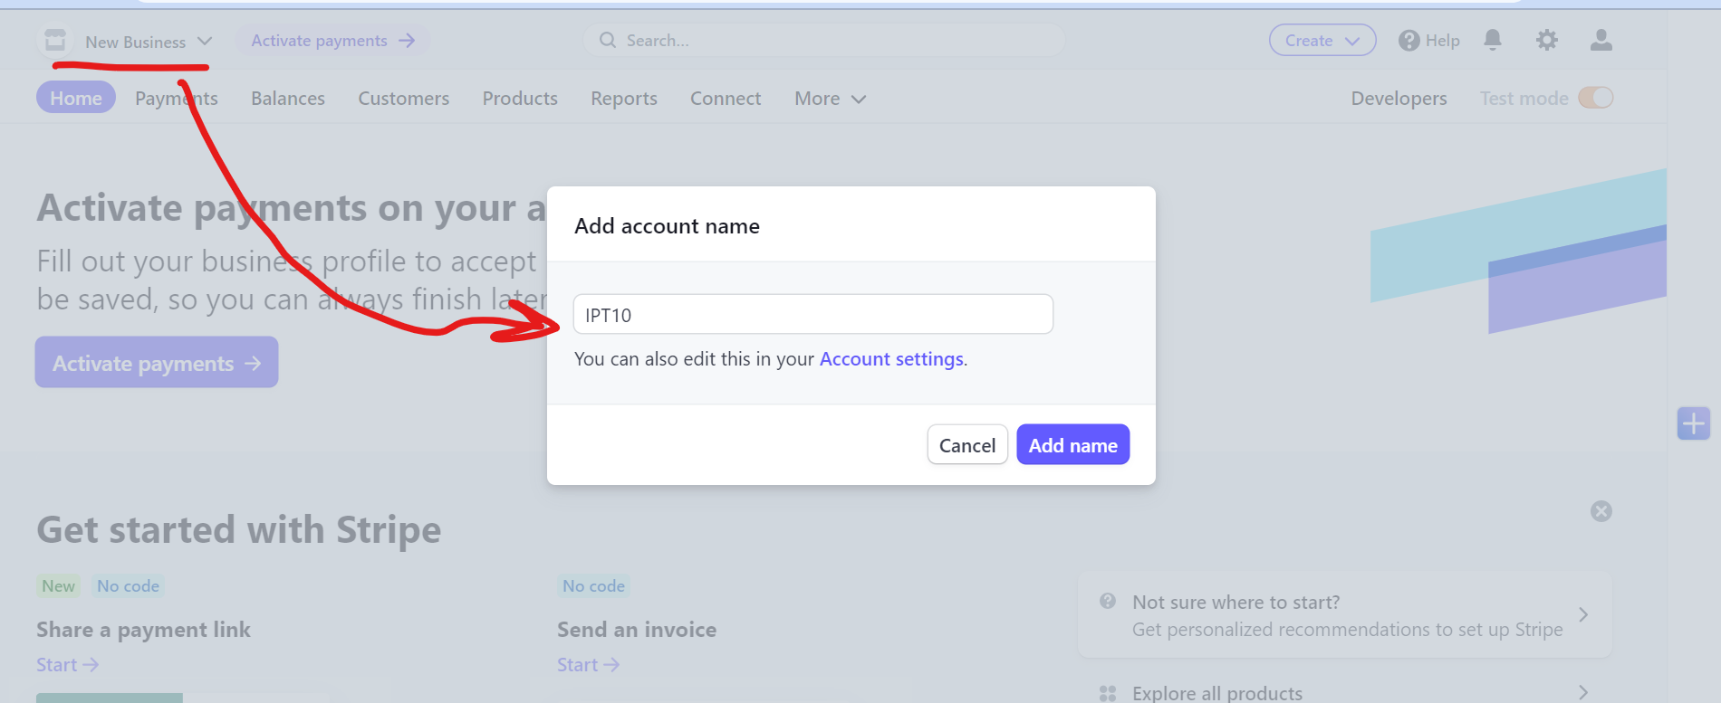

* Setup Stripe CLI (follow this link <https://stripe.com/docs/stripe-cli> )
  + Download the latest version for your OS (Windows, Mac, Linux)
  + Extract it in your stripe folder

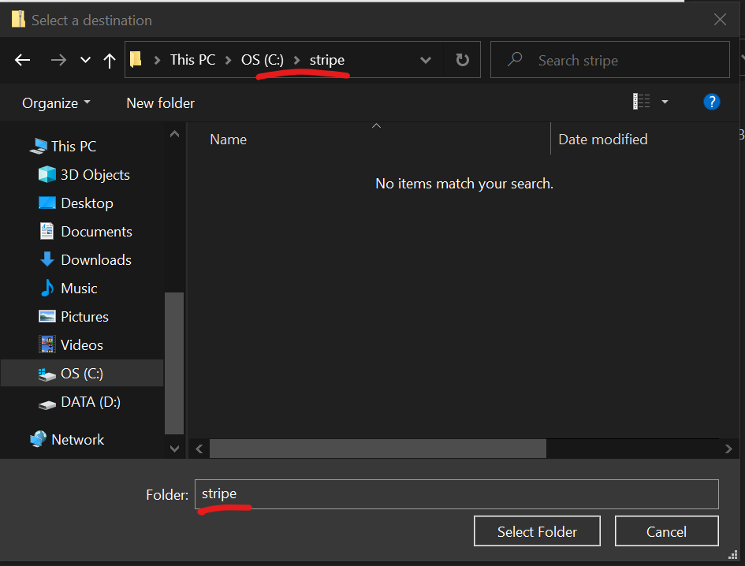

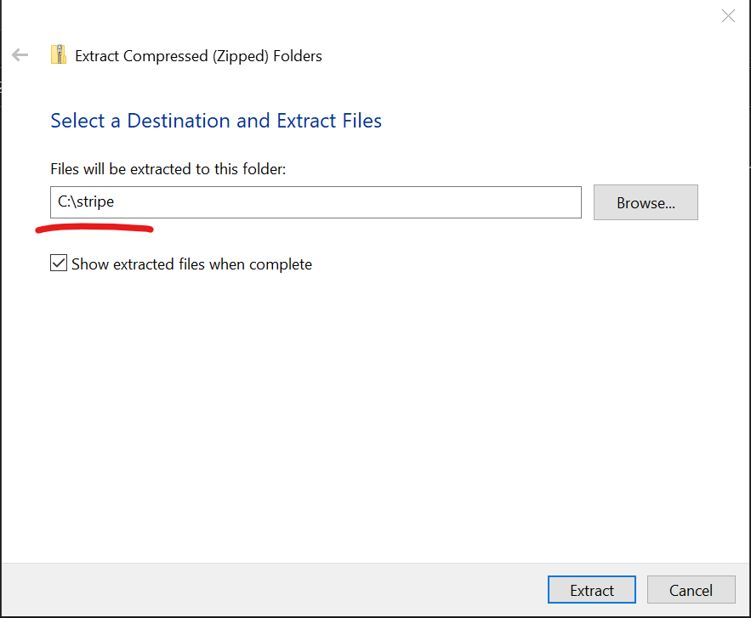

* Login to Stripe CLI (follow the instructions for logging in using this link <https://stripe.com/docs/stripe-cli> )
  + Open the API Keys (<https://dashboard.stripe.com/test/apikeys>) if your workstation has successfully authenticated
  + Grab a screenshot and paste below
* Run the stripe listener, and just leave it open, regularly check it to monitor your API calls
  + **stripe.exe listen**

### Create a Payment Link

* Create a payment link for a product
* Customize the product information and confirmation page

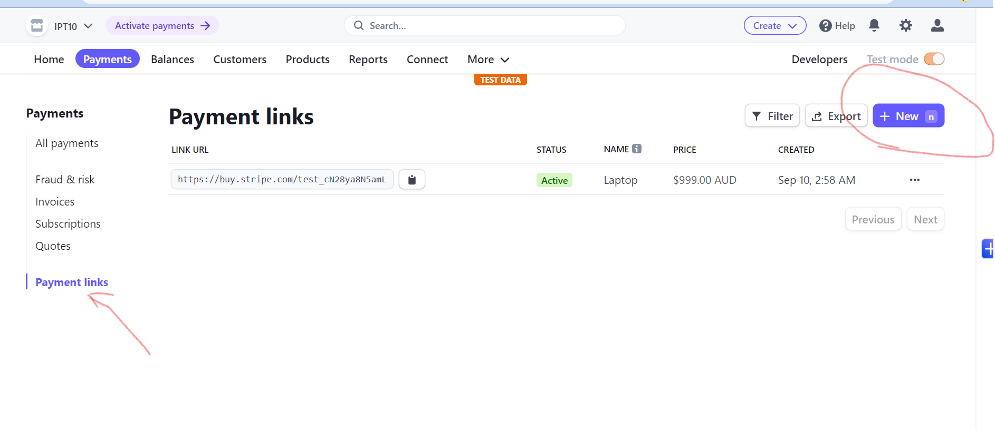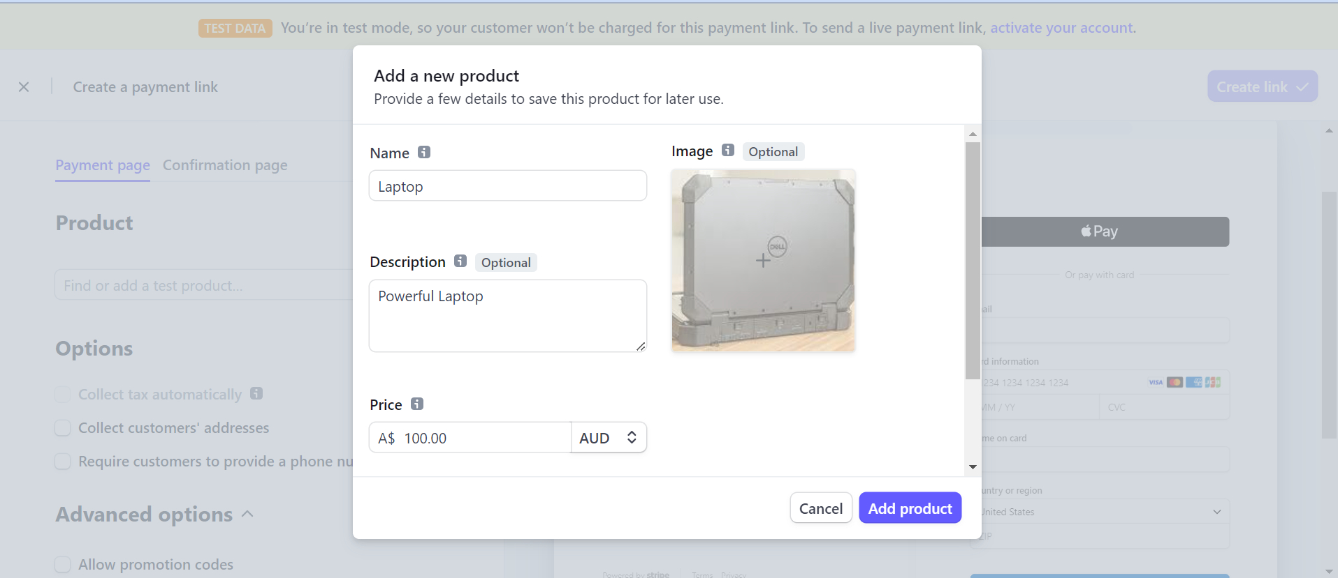

* Save the Payment Link
  + Grab a screenshot and paste below
* Open the payment link and test buying the product using TEST Credit Cards
  + Find cards here <https://stripe.com/docs/testing>
* Verify the payment in your stripe account
  + Grab a screenshot and paste below

### Stripe API

By default, stripe has generated API keys for your account. You will need those credentials for the following API integrations.

* Using the command line, go to your stripe folder and run the following
  + composer init
    - Just follow through to complete the initialization
  + composer require stripe/stripe-php

Note: you will need to add the following code to each of your PHP file that integrates with Stripe API

<?php

require "vendor/autoload.php";

### Create a Product

Reference: <https://stripe.com/docs/api/products/object?lang=php>

* In your **stripe/** folder, create a file named **create-product.php** file

Sample code

<?php

require "vendor/autoload.php";

$stripe = new \Stripe\StripeClient(

'sk_test_?????'

);

$result = $stripe->products->create([

'name' => 'Pandesal',

]);

var_dump($result);

* Run the create-product.php file in your command line or your browser
  + php create-product.php
* Verify if the product has been added

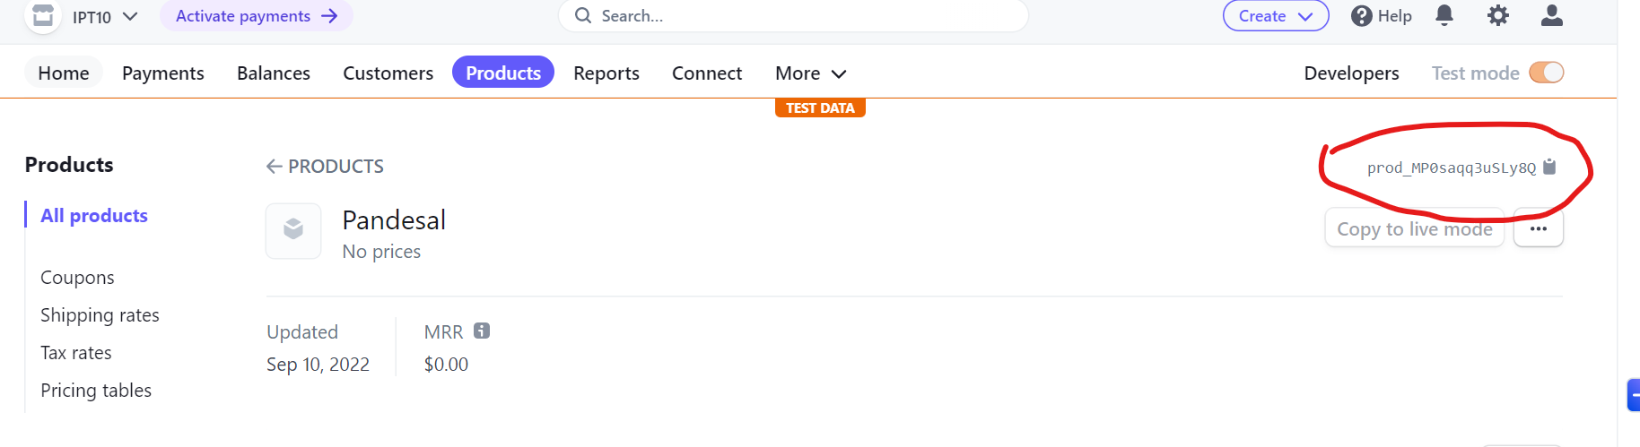

* Copy the product code
* Modify your create-product.php and three (3) more products

### Retrieve the product

Reference: <https://stripe.com/docs/api/products/retrieve?lang=php>

* In your **stripe/** folder, create a file named **retrieve-product.php** file
  + You would need the product code to achieve success here
* Run the retrieve-product.php file in your command line or your browser
  + php retrieve-product.php
* Grab a screenshot of the result and paste below

### List all Products

Reference: <https://stripe.com/docs/api/products/update?lang=php>

* In your **stripe/** folder, create a file named **all-products.php** file
* Run the **all-products.php** file in your command line or your browser
  + **php all-products.php**
* Grab a screenshot of the result and paste below

### Delete a Product

Reference: <https://stripe.com/docs/api/products/delete?lang=php>

* In your **stripe/** folder, create a file named **delete-product.php** file
* Run the **delete-product.php** file in your command line or your browser
  + **php delete-product.php**
* Grab a screenshot of the result and paste below

### Starter Subscription

Reference: <https://stripe.com/docs/development/quickstart/php#test-install>

* In your **stripe/** folder, create a file named **starter-subscription.php** file
* Run the **starter-subscription.php** file in your command line or your browser
  + **php starter-subscription.php**
* Grab a screenshot of the result and paste below

### Display a Single Product

* Manually create a new product in stripe (<https://dashboard.stripe.com/test/products?active=true>)
  + Upload an image
  + Add a description
  + Add a price (one time)
* Create a PHP file that will retrieve the newly-created product
  + Sample <https://www.behance.net/gallery/138779623/Single-Product>
  + Create a balsamiq mockup for a single product page
    - Open balsamiq, design a single product page
    - Export the design and paste below
* Your page should display the product information including the
  + Product Name
  + Description
  + Picture
  + Price (<https://stripe.com/docs/api/prices/retrieve?lang=php>)

Sample: <https://gist.github.com/itsromack/dc658c6c5d5126a209a0064a8c6b1dcc>

* Grab a screenshot of your page and paste below

### Checkout your Product

Reference: <https://stripe.com/docs/checkout/quickstart>

* In your **stripe/** folder, create a file for your single product page, name it **my-product.php**
* From your single product page, create a checkout workflow for your product
  + You need the correct price ID for your product
* Once you have successfully integrated your product page into the checkout session, you would be redirected to the stripe checkout page, pay the product using a test card
  + Find cards here <https://stripe.com/docs/testing>

Push all your changes to your GITHUB repository

* Paste the github repository below